The commissioning progress of microwave imaging reflectometer on EAST tokamak

Lifu ZHANG,a Jinuo Yu,a Jinchen Yang,a Ge Zhuanga and Jinlin XIE a,1

1. Department of Plasma Physics and Fusion Engineering, USTC,  
   Hefei, China

*E-mail*: jlxie@ustc.edu.cn

Abstract: A 96-channel W-band (75–110 GHz) microwave imaging reflectometer (MIR) has been designed and developed for 2D electron density fluctuation measurements on the Experimental Advanced Superconducting Tokamak (EAST). The system features 12 poloidal channels with eight distinct radial viewing depths. An advanced front-end transmitter and receiving optics system has been implemented on-site, offering extensive flexibility for various plasma scenarios through dynamic adjustments of the transmitter beam wavefront shape, poloidal zoom, and full-frequency radial focus depth. The experiment’s signal-to-noise ratio has been enhanced by increasing the MIR illumination system’s output power. To minimize crosstalk, the eight-tone reflectometer frequencies are selected with gaps. The thresholds for signal-to-noise ratio and fluctuation reconstruction uncertainty have been quantitatively evaluated through precise bench-top experiments. Clear observations of 1D poloidal coherent modes have been achieved using the EAST MIR system.

Keywords: Density fluctuation; Microwave reflectometry; Space echo.

Contents

1. Introduction 1

2. Plasma Accessibility 3

3. MIR Hardware 3

3.1 Upgrade of RF system 3

3.2 The receiving system electronics 5

3.3 The MIR optics system 6

4. The labortory testing for MIR performance validation 7

4.1 Low signal to noise ratio on experimental measurement 7

4.2 The MIR system performance laboratory testing 8

4.3 Signal to noise ratio threshold assessment in the laboratory testing 9

5. Preliminary EAST plasma results by the MIR system 9

6. Summary 12

1. Introduction

Active microwave reflectometer is widely employed for both electron density equilibrium profile and fluctuation measurements [1-4]. The cutoff layer is usually assumed to be an ideal flat surface for reflection, which ensures a neat interpretation of the diagnostic data. For instance, the density fluctuation level is proportional to the phase variation level. However, the assumption is questionable in real case considering the 2-D density fluctuations (both in the radial and in the poloidal direction) developed on cutoff layer with different spatial scales. Consequently, the perturbed cutoff layer would act like a diffraction grating and the reflected wave scatters over a large solid angle. Since the distance between the cutoff layer and the receiver is usually much larger than the “diffraction distance”, the possible resulted interference will make it difficult to interpret data. Thus a front-end Gaussian optical collective receiving system with large-aperture is proposed to help reconstruct the correct wavefront at the receiver position [5-6], which re-assure the clean and simple data interpretation. With the aid of large-aperture optical collective receiving system, it is nature to replace the single detector with 1-D detector vertical array and increase the number of transmitter frequencies, which realize the microwave imaging reflectometer (MIR) diagnostic system [7-8]. With the capability to visualize the 2D electron density fluctuations in the poloidal and radial cross-section on the Tokamaks and Stellarators, MIR systems had been developed in TEXTOR [9], DIII-D [10], WEST [11], KSTAR [12], LHD [13] and HL-2A [14]. Unlike the passive 2D imaging radiometer, Electron Cyclotron Emission Imaging (ECEI), MIR measurements encounter greater challenges in achieving clear 2D density fluctuation imaging. These challenges stem from complex coherent wave receiving, interference between different poloidal and radial channels, and potential misalignment between the transmitter wavefront and the plasma cutoff layer. Despite these difficulties, the MIR system offers a unique capability for co-located and simultaneous measurements of both density and temperature fluctuations alongside ECEI. This capability is essential and highly valuable for studying MHD instabilities and turbulence transport in long-pulse plasma discharges. A clear understanding of these physical phenomena is crucial for the design and safe operation of fusion plasma devices.

The EAST MIR system was developed and implemented following the laboratory characterization [15], sharing part of its front-end optics and vacuum port with the Electron Cyclotron Emission Imaging diagnostic, as illustrated in Fig. 1. The MIR transmitter beam operates at eight distinct frequencies, enabling density fluctuation measurements at varying depths. The transmitter optics adjust the beam wavefront to closely match the curvature of the plasma cutoff layer, ensuring near-normal incidence across different poloidal heights for 2D measurements [16]. This wavefront matching maintains a nearly constant phase front at the fluctuating cutoff layer, optimizing the coupling of reflected beam power back to the receiver system and enhancing measurement signal quality. The receiving optics then collect the reflected beams from the curved plasma cutoff layer. As depicted in Fig. 1, a W-band beam splitter separates the transmitted and received beams. The spatial structure of density fluctuations near the cutoff layer is reconstructed by analyzing the reflected wavefront at the image plane, preserving the accuracy of phase measurements. [17].

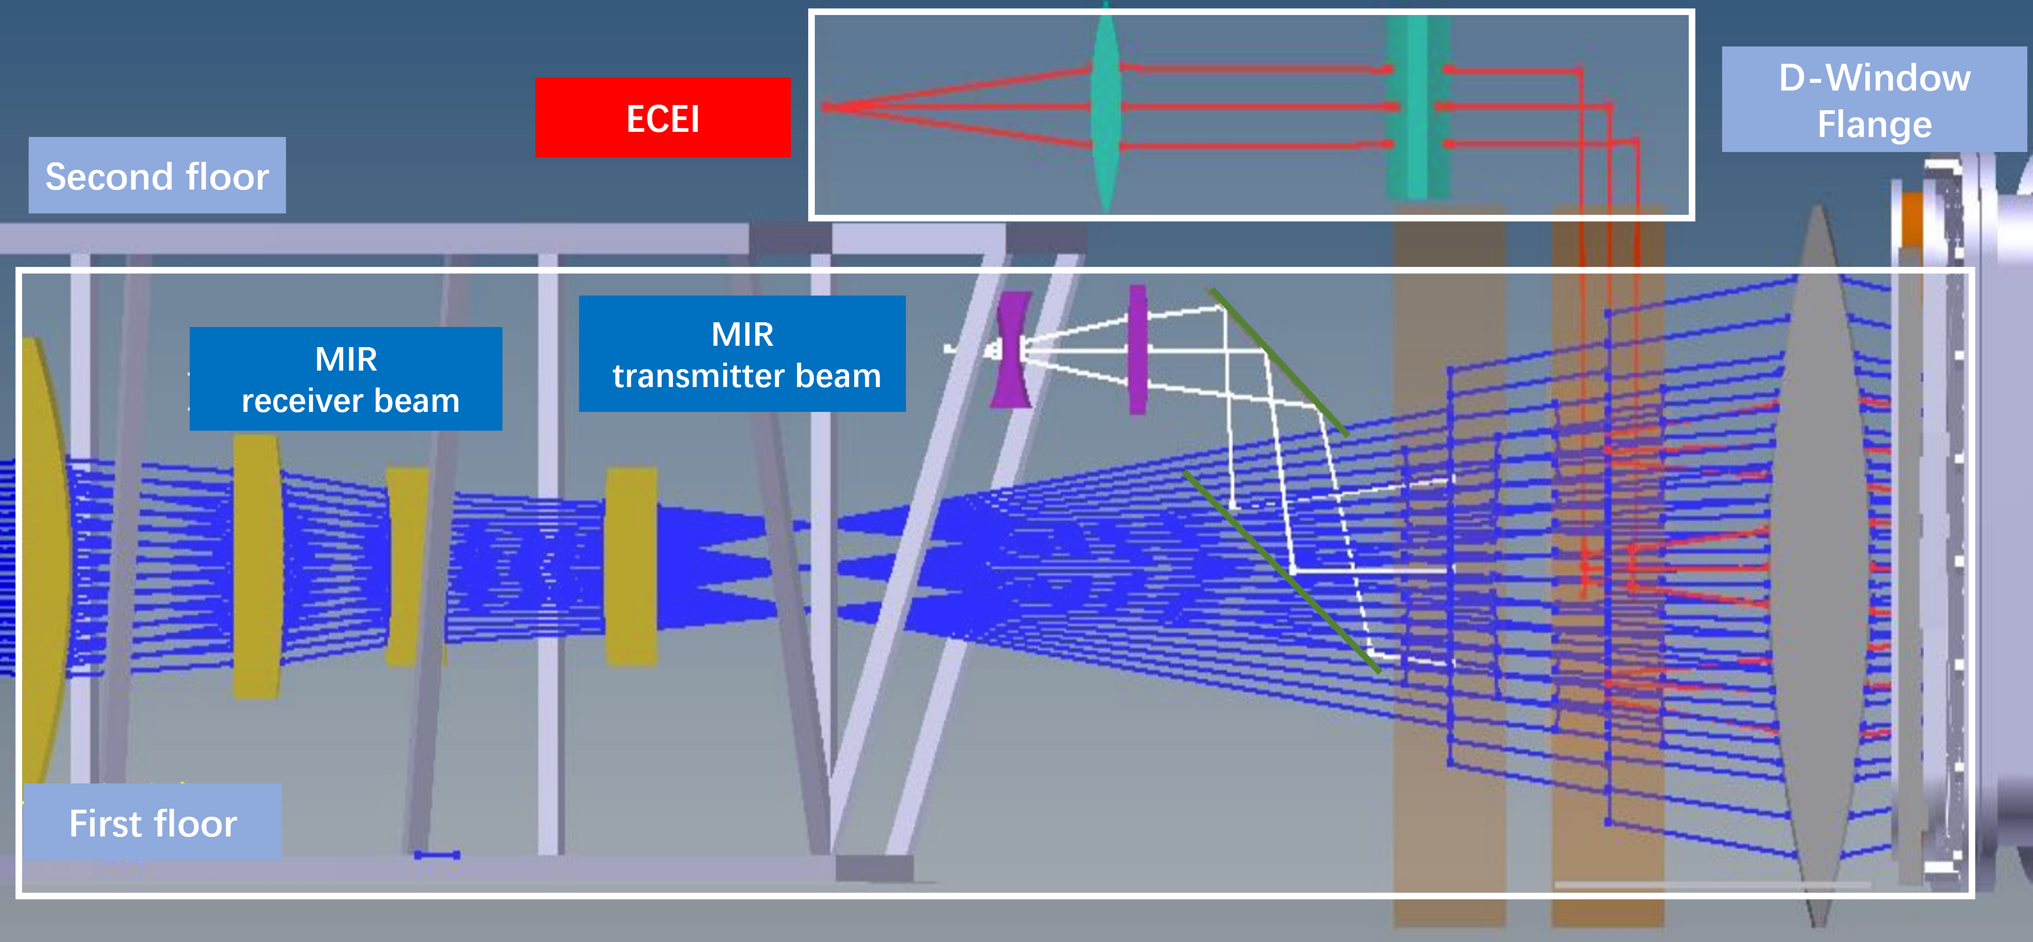

**Figure 1. Schematic of the 2-D Microwave Imaging Reflectometer (MIR) diagnostic on EAST. The MIR system shares part of front-end optics and observation window with Electron Cyclotron Emission Imaging (ECEI) diagnostic. They are used for co-located and simultaneously measurements of electron density and temperature fluctuations.**

This paper presents an overview of the hardware design and challenges encountered during the implementation of the EAST MIR system. Section II discusses the fundamental constraints on MIR, focusing on plasma accessibility. Section III covers the transmitter and receiver optical systems and electronics, including upgrades to the transmitter source, suppression of back-end electronics crosstalk, and improvements in optical performance. In Section IV, the artificial phase modulation testing platform is described, along with laboratory test results that quantitatively assess the thresholds for signal-to-noise ratio and fluctuation reconstruction uncertainty. Section V presents preliminary plasma measurement results from EAST. Finally, Section VI summarizes the status of the EAST MIR system and ongoing efforts to enhance signal quality. Preliminary experimental results of the MIR system on EAST.

1. Plasma accessibility

Based on the standard EAST discharge configuration, the radial distribution of plasma characteristic frequencies with a toroidal magnetic field around 2.3 T is shown in Fig. 2. The MIR transmitter beam, consisting of eight different frequencies, is launched from the low-field-side vacuum window. The transmitter frequencies are carefully selected to match the cutoff frequencies at the targeted radial depths while avoiding resonance layers along the propagation path. As shown in Fig. 2, the W-band (75-110 GHz) frequency range provides wide radial accessible range (normal radius from 0.6 to 0.9) with X-mode operation mode.

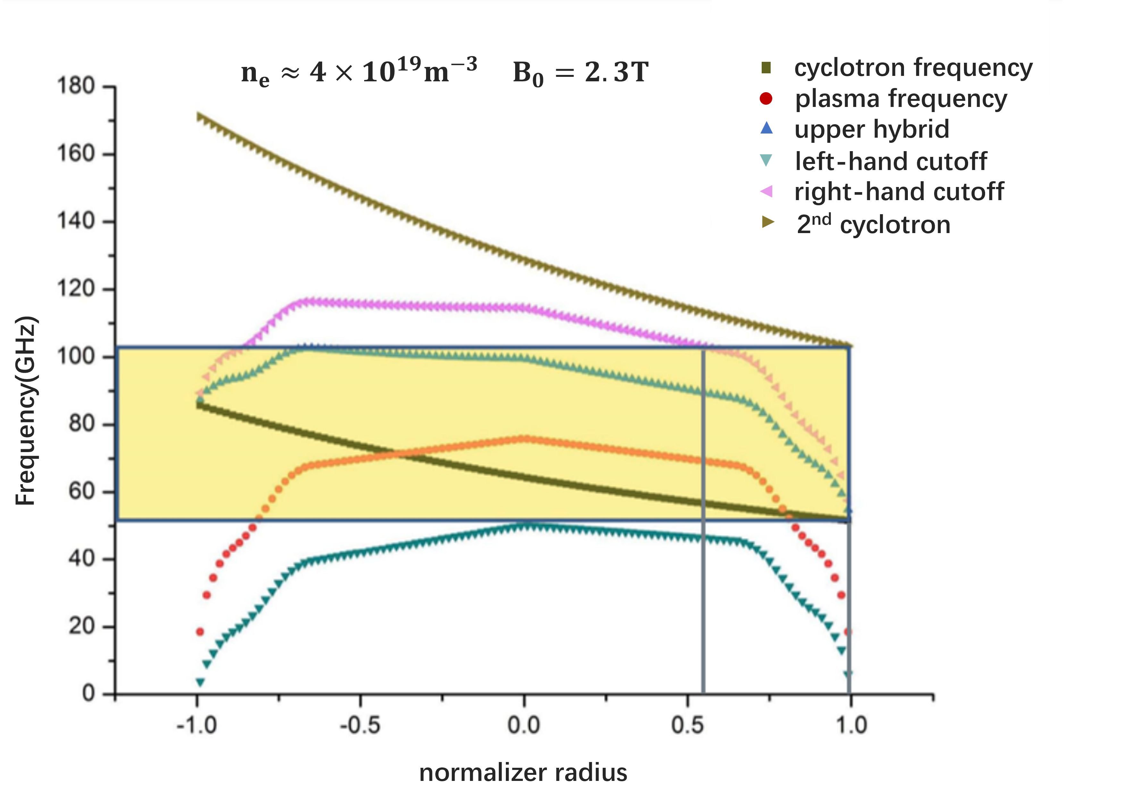

**Figure 2.** the operation frequency ranges of MIR (yellow) in EAST tokamak.

1. MIR hardware description
   1. Upgrade of transmitter system

The transmitter source functions as the "camera flash," emitting multi-frequency signals onto the plasma cutoff layers. The received power maintains an approximately linear relationship with the transmitted power. W-band transmitter frequencies are generated using low-frequency synthesizer sources (0.65–20 GHz) and the 6x active multipliers. The diagram of transmitter source is shown in Fig. 3. An 8-input, 1-output W-band waveguide signal combiner is utilized to transmit eight independent frequency signals through a single port.

The initial transmitter source, installed in 2019, delivered a maximum output power of approximately 3 dBm (~2 mW) on each frequency. However, performance degradation was observed over time due to aging coaxial cables, inadequate grounding, and insufficient cooling caused by poor system arrangement.

The transmitter source upgrade has been completed and implemented on the EAST MIR diagnostic. As shown in Fig. 3a, a low-noise amplifier has been installed between the 8-way power combiner and the transmitter horn. This amplifier provides a maximum gain of 20 dB across all eight transmitter frequencies, with a min P1dB of -3 dBm and a noise figure of 3.5 dB. The amplifier’s frequency coverage ranges from 75 to 105 GHz, meeting the requirements for MIR measurements. Additionally, the transmitter enclosure has been redesigned to include improved cooling, optimized wire connections, and enhanced accessibility for maintenance.

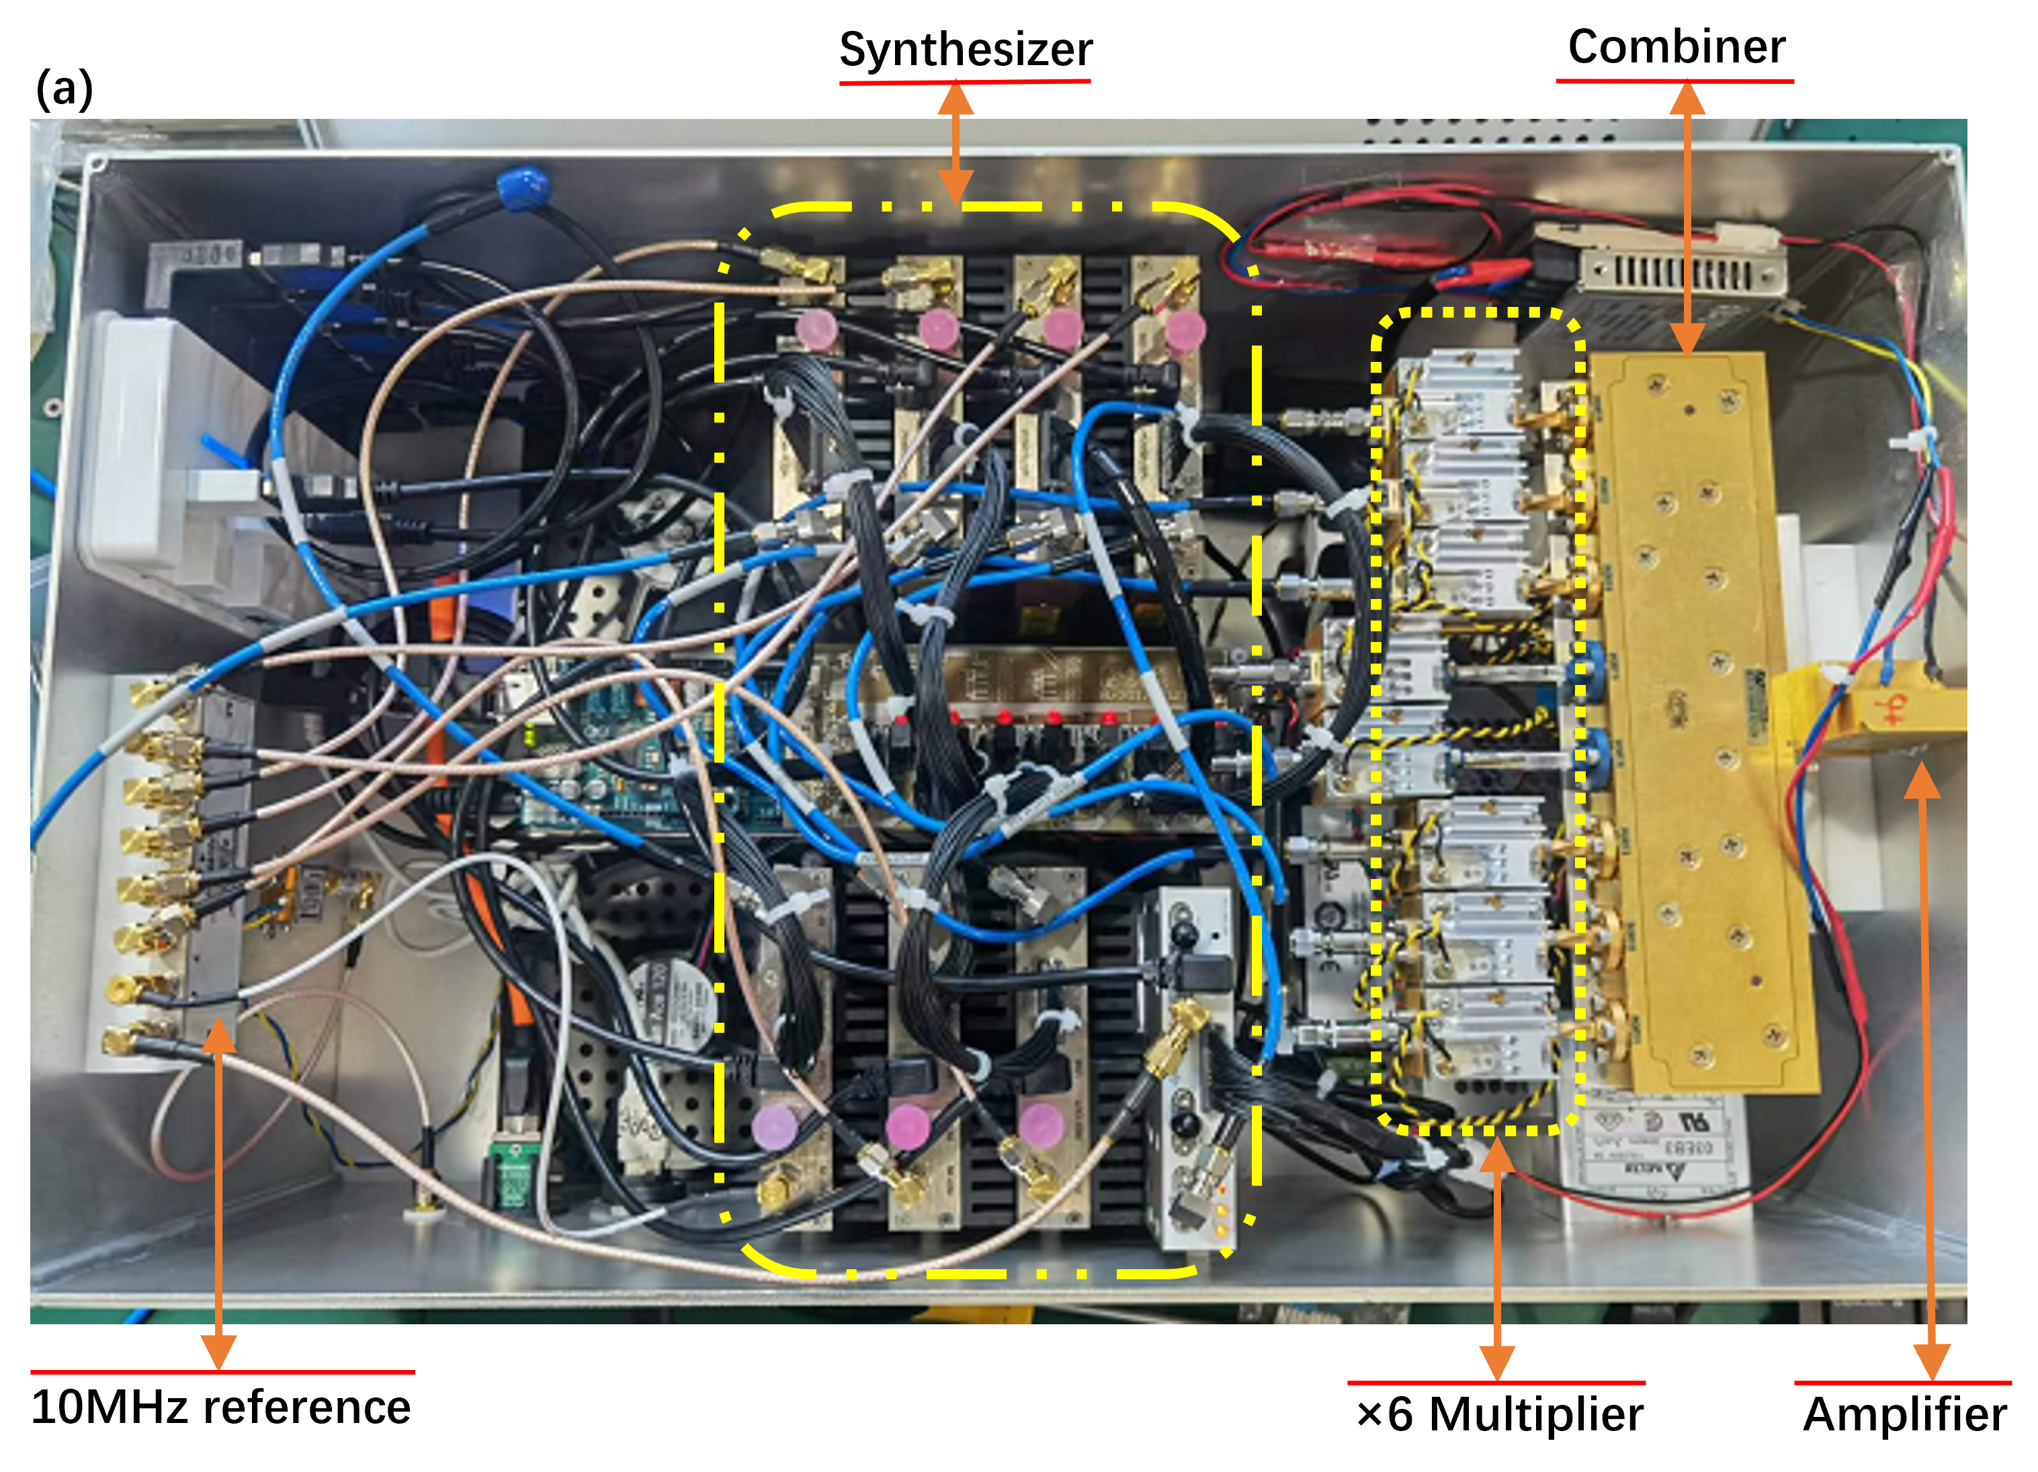

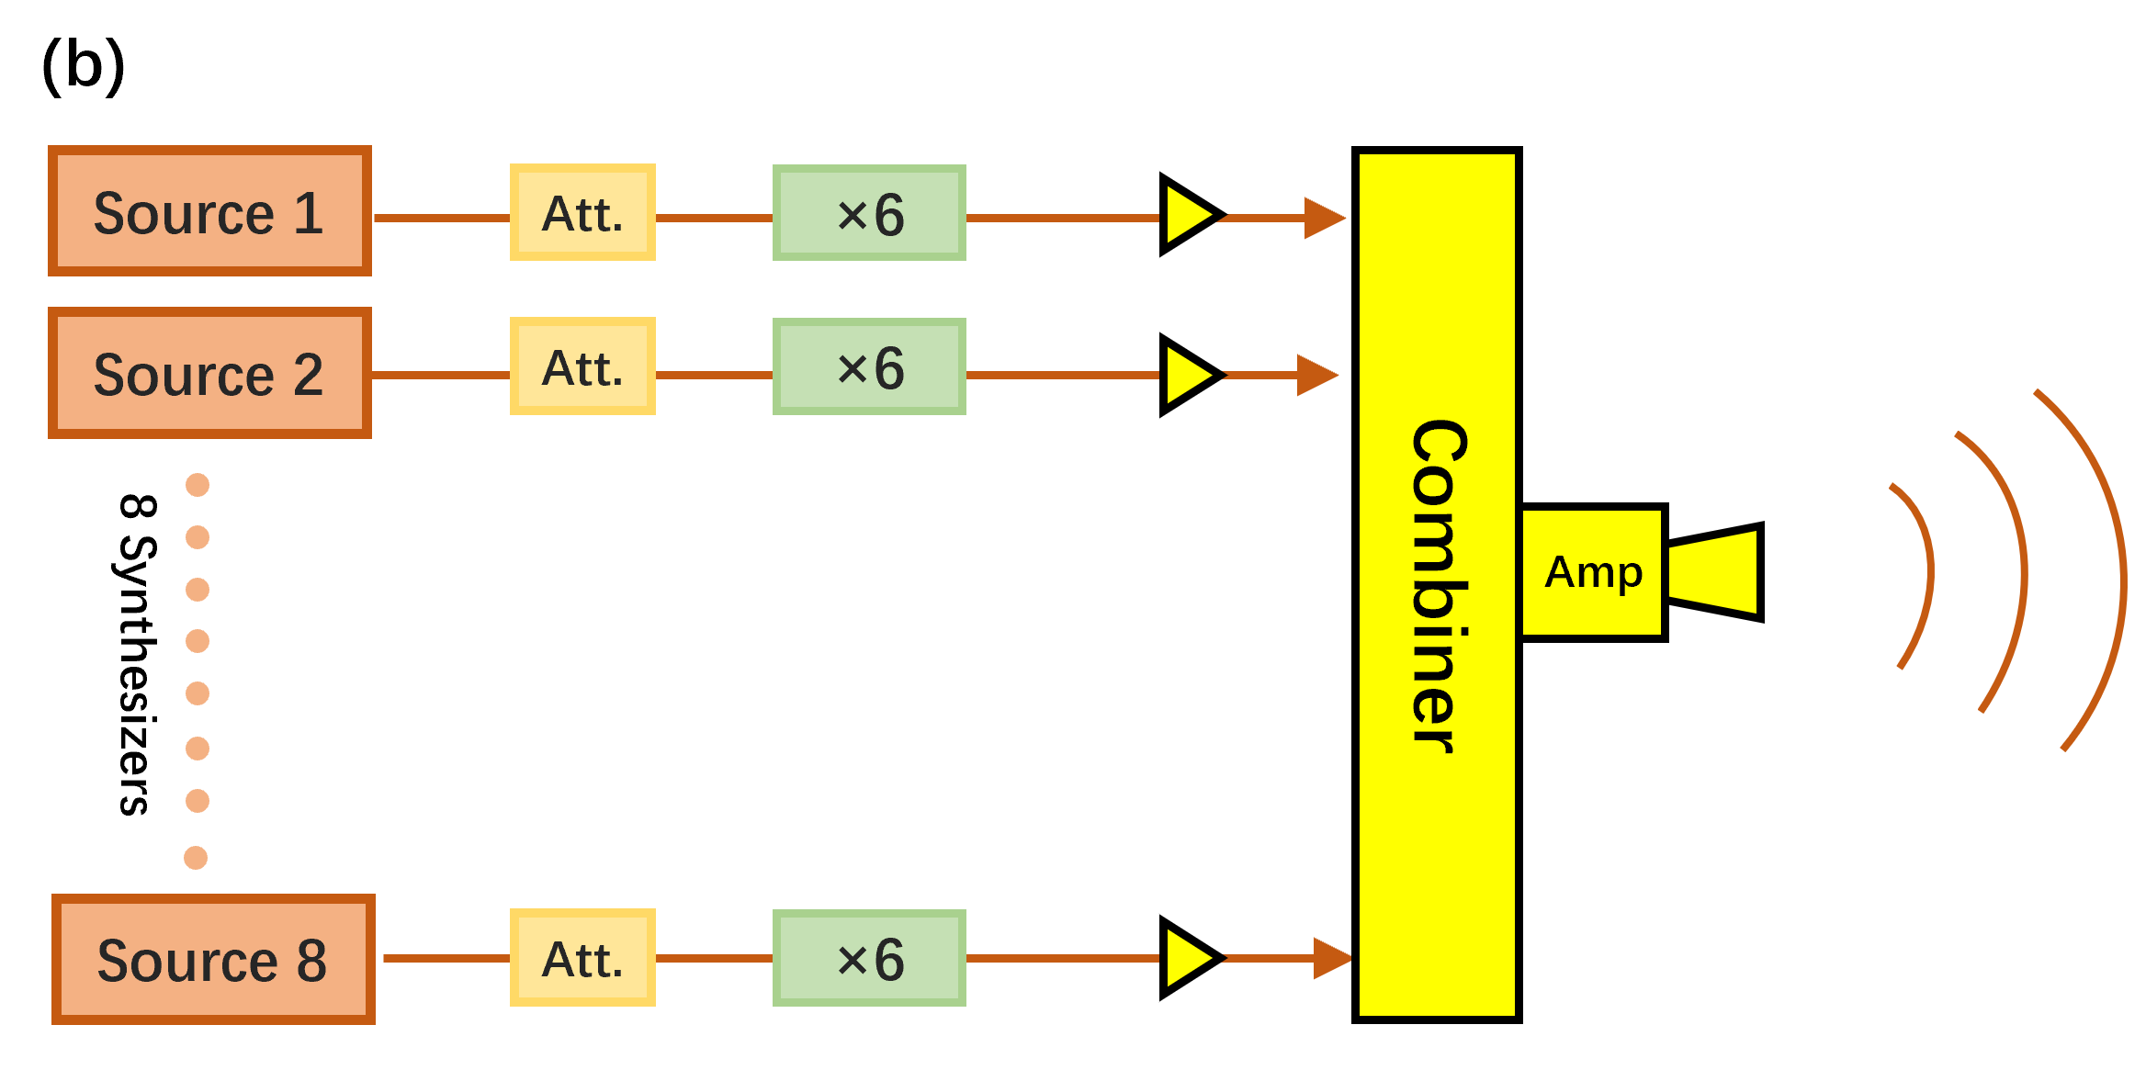

**Figure 3.** (a) the upgraded transmitter source; (b) the schematic diagram of transmitter source.

* 1. The receiving system electronics

Figure 4 shows the schematic of EAST MIR back-end electronics module. Twelve W-band receiver antennas are placed in vertical arrays for receiving 8-tone reflected beams from 12 heights in the plasma side, through front-end receiving optics. The receiving signal is down-converted mixing with local oscillator (LO) signal which coupling by separate LO optics. The heterodyne mixing output bandwidth covers 2-18 GHz. The back-end electronics modules, following the heterodyne mixers, are used to extract the phases from 8 different frequencies.

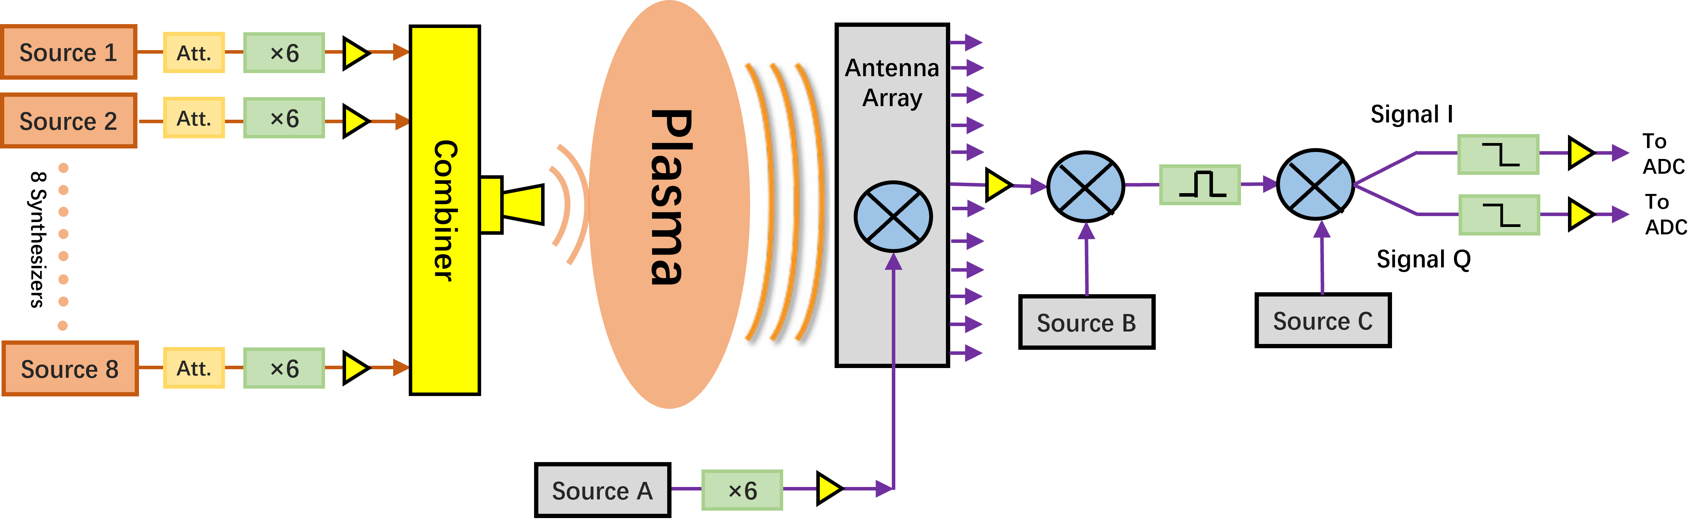

**Figure 4. The EAST Microwave Imaging Reflectometer (MIR) receiver system consists of multiple signal sources and components for high-frequency microwave imaging. Source A generates a signal that passes through a 6× active multiplier chain to produce the local oscillator (LO) signal for the receiver electronics. Source B drives the mixer in the receiver system, working with a band-pass filter to enable proper frequency selection. Source C provides a 140 MHz reference signal to drive the I/Q mixers, facilitating quadrature demodulation for extracting phase and amplitude information.**

Each individual back-end electronics unit, corresponding to a single poloidal antenna, receives an 8-tone down-converted signal. This signal is a mix of the plasma-reflected beam and the local oscillator signal. The 1 to 8 power divider, as shown in Fig. 5, is used to deliver 8 identical samples to each sub-intermediate frequency arm. The reference signal from external synthesizer drives the second-stage mixer mixing with 8-tone sample. The narrow bandpass filter 140 ± 18.4 MHz is placed after the second-stage mixer, which only filter out one selected frequency in need, which determined by external synthesizer source frequency. Eight individual synthesizers are used for 8-tone signal filter and selections. Their output signals (140 ± 18.4 MHz) deliver to following I/Q mixers for phase detection.

An external 10 MHz clock signal is used to synchronize the clocks of all synthesizers within the entire MIR system, including the 8 synthesizers in the transmitter, 8 in the receiver, 1 in the local oscillator, and all I/Q mixer drivers.

During laboratory bench-mark testing, crosstalk between different sub-intermediate frequency arms was clearly observed. This crosstalk couples through the microstrip transmission lines on the printed circuit boards, causing non-negligible interference in phase detection. Removing the crosstalk is challenging with the current design, as the circuit boards are in close proximity within a limited space. However, optimizing the frequency separation between synthesizers helps mitigate the crosstalk issue, significantly improving the phase signal purity on each channel.

To facilitate understanding, an example of MIR frequency settings is provided. The eight frequency points for the transmitter source are set as follows: 82.74 GHz (13.79 GHz × 6, then continuing in this pattern), 82.02 GHz, 81.24 GHz, 80.4 GHz, 79.5 GHz, 78.54 GHz, 77.52 GHz, and 76.38 GHz. The frequency of the antenna's local oscillator is set to 84.3 GHz. After a single mixing process, the intermediate frequency (IF) signal components obtained by a single antenna mixing reception module include: 1.56 GHz, 2.28 GHz, 3.06 GHz, 3.9 GHz, 4.8 GHz, 5.76 GHz, 6.78 GHz, and 7.92 GHz. The output frequency of the module's local oscillator is set to 1.70001 GHz. The IF signal for radial channel 1 in the intermediate frequency electronics module, after mixing with the local oscillator signal, results in output frequencies of: 140.01 MHz, 579.99 MHz, 1.35999 GHz, 2.19999 GHz, 3.09999 GHz, 4.05999 GHz, 5.07999 GHz, and 6.21999 GHz. Among these, only 140.01 MHz can pass through the subsequent 140 MHz ± 18.4 MHz bandpass filter, while other frequencies are filtered out. The 140.01 MHz signal that passes through the bandpass filter is then mixed by the IQ phase detector, with the phase detector's LO frequency set to 140 MHz. The resultant carrier signal corresponding to radial channel 1 after mixing is 10 kHz. Similarly, by setting the frequencies of the remaining seven local oscillator sources in the module, the eight frequency points of the illumination source correspond to eight different carrier frequencies, achieving reliable radial resolution measurements in the intermediate frequency electronics module.

* 1. The MIR optics system

The diagram of the EAST MIR optics system is shown in Fig. 5, which includes both the transmitter and receiver optics. Optimal optics alignment and coupling are essential for reliable density fluctuation measurements. It requires (1) transmitter beam wavefront, (2) receiver array image plane, and (3) cutoff layer in the plasma matches with each other.

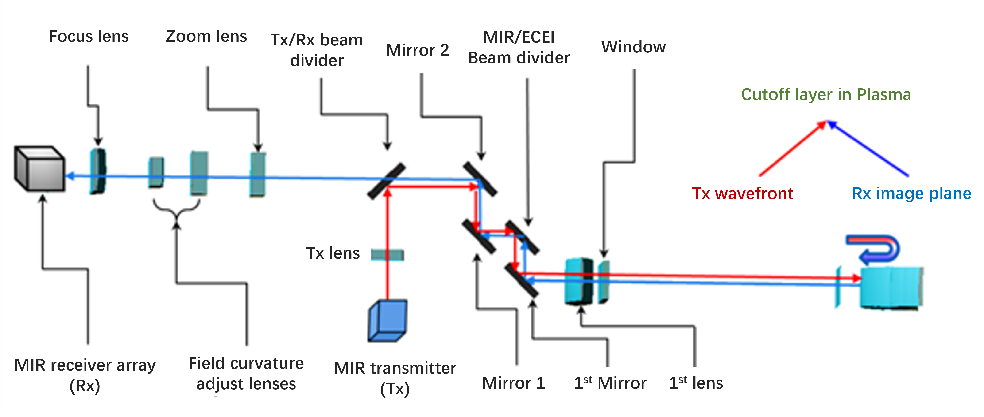

**Figure 5. The transmitter and receiver optics diagram of EAST Microwave Imaging Reflectometer.**

The MIR system measurable region covers major radius (R) from 2.2 to 2.43 m. , based on the standard EAST plasma equilibriums (EAST shot #132368). The transmitter wavefront curvature radius is dynamically adjustable from 640 mm to 1560 mm to accommodate different EAST plasma scenarios. On the receiver side, five high-density polyethylene (HDPE) lenses and two flat mirrors are used to receiver the reflected waves from the plasma, and direct them to the 12-channel antenna array [18]. The image plane curvature radius ranges from 570 mm to 850 mm, depending on the plasma scenario. The spatial spacing between neighbor radial channels is adjustable from 18.8 mm to 30.8 mm, allowing for the study of different-scale radial transport physics.

1. The MIR performance validation
   1. Low signal to noise ratio on experimental measurement (before diagnostic setup optimization)

The quality of MIR data is closely tied to optics alignment. When misalignment occurs [19], the reflected beam fails to be accurately received by the designated receiver antenna. Instead, it spreads into a larger beam spot, covering multiple receiver antennas, which induces crosstalk between different poloidal channels. In a single-transmitter system, this crosstalk directly introduces interference, compromising the integrity of the raw data. During actual measurements, this interference appears as "dark zones," where signal intensity is reduced, and the signal-to-noise ratio deteriorates.

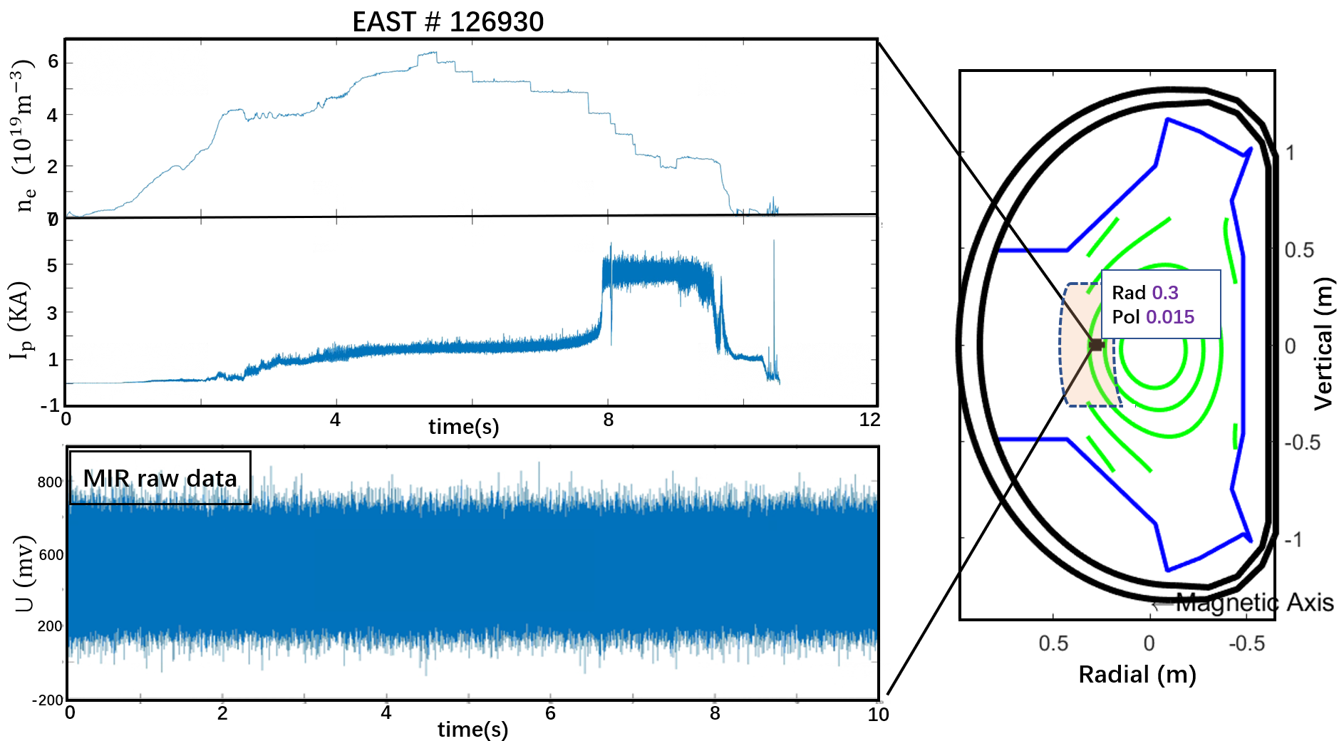

**Figure 6. (a) The average electron density during EAST shot # 126930, with xx T on-axis magnetic field. (b) The plasma current (c) The raw data of MIR diagnostic (optics misalignment) (d) Selected MIR channel locates at (R,Z) = (xx, yy) m.**

For instance, Fig. 6 presents the selected MIR in-phase channel raw signal on EAST (EAST shot 126930). It is evident that signal intensity remains largely unchanged during the current ramp-up and plateau phases. This outcome highlights the severe impact of optical misalignment, reinforcing the fact that data quality is a direct indicator of optics alignment.

Optics misalignment also introduce unexpected reflections (not from plasma cutoff layer), which appear as fixed pattern that remain unchanged regardless of plasma discharge conditions. Despite their static nature, these reflections are still received by the receiving system, degrading overall signal quality. To mitigate this issue, further optimization of the optics design and setup is essential to minimize the impact.

* 1. The MIR system performance testing in laboratory

To quantitatively evaluate the impact of unexpected reflections on MIR signals, a dual-arm differential power testing platform was developed, as shown in Fig. 7. The transmitter power originates from a synthesizer operating below 20 GHz, which uses an active multiplier chain (6x) to generate a 79.5 GHz signal. This signal is then split byan 1 to 2 power divider, resulting in a dual-arm balanced output system.

As depicted in Fig. 7, two identical gain horns are mounted on the top and bottom output ports. The bottom beam follows a free propagation path, while the top beam path incorporates an external chopper module equipped with high-density polyethylene (HDPE) blades. The rotation of the chopper introduces phase jumps in the top beam propagation path, simulating plasma density fluctuations.

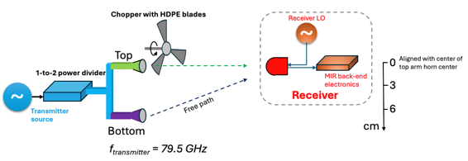

**Figure 7.** Schematic diagram of the chopper experiment setup.

The receiver is put on the beam propagation regions of both top and bottom paths. The propagation distances between transmitter horns to receiver antenna are different, which brings differential power testing capability. We could adjust the input power ratio (Ptop / Pbottom) by moving receiver antenna position.

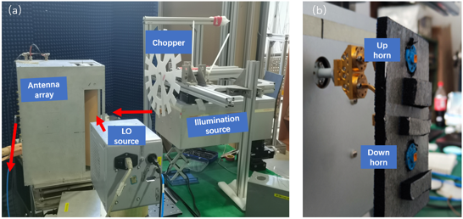

**Figure 8.** (a) table layout of the chopper experiment setup; (b) the waveguide power divider used to introduce space echo effect..

* 1. Signal to noise ratio threshold assessment in the laboratory testing

The frequency difference between transmitter source and receiver detection channel is set as 120 kHz, which stands in the standard density fluctuation range (20 – 400 kHz). The output power of 120 kHz is linear related to transmitter power. In the laboratory testing, we reset the receiver height to 0, which means stands on the same level with the top-arm.

We sequentially open the top and bottom channels, ensuring that while one channel is open, the other is blocked using absorbing material, while keep the chopping turned on. By measuring the power response of each channel at the receiver, the input power ratio Ptop / Pbottom is approximately 2.84. In the next step, both the top and bottom channels are opened simultaneously. The top path, with phase jumps, simulates the plasma reflection beam with phase modulation, while the bottom path represents unexpected reflections. Both signals are received by the receiver. The receiver clearly detects the phase jumping, as illustrated in Fig. 8a, with an input power ratio of Ptop / Pbottom = 2.84. This indicates that the signal-to-noise threshold remains in the region corresponding to lower input power ratios.

We finely adjust the receiver height and repeat the measurements to analyze phase measurement results at varying input power ratios in Fig. 9. In **Case I**, with an input power ratio of 2.84, the phase modulation is clear and aligns well with the chopper modulation. In **Case II**, shifting the receiver 3 cm downward reduces the input power ratio to 1.97, leading to noticeable phase distortion. Finally, in **Case III**, with a 6 cm downward shift, the input power ratio drops further to 1.46, making it nearly impossible to interpret phase modulation from the raw data.

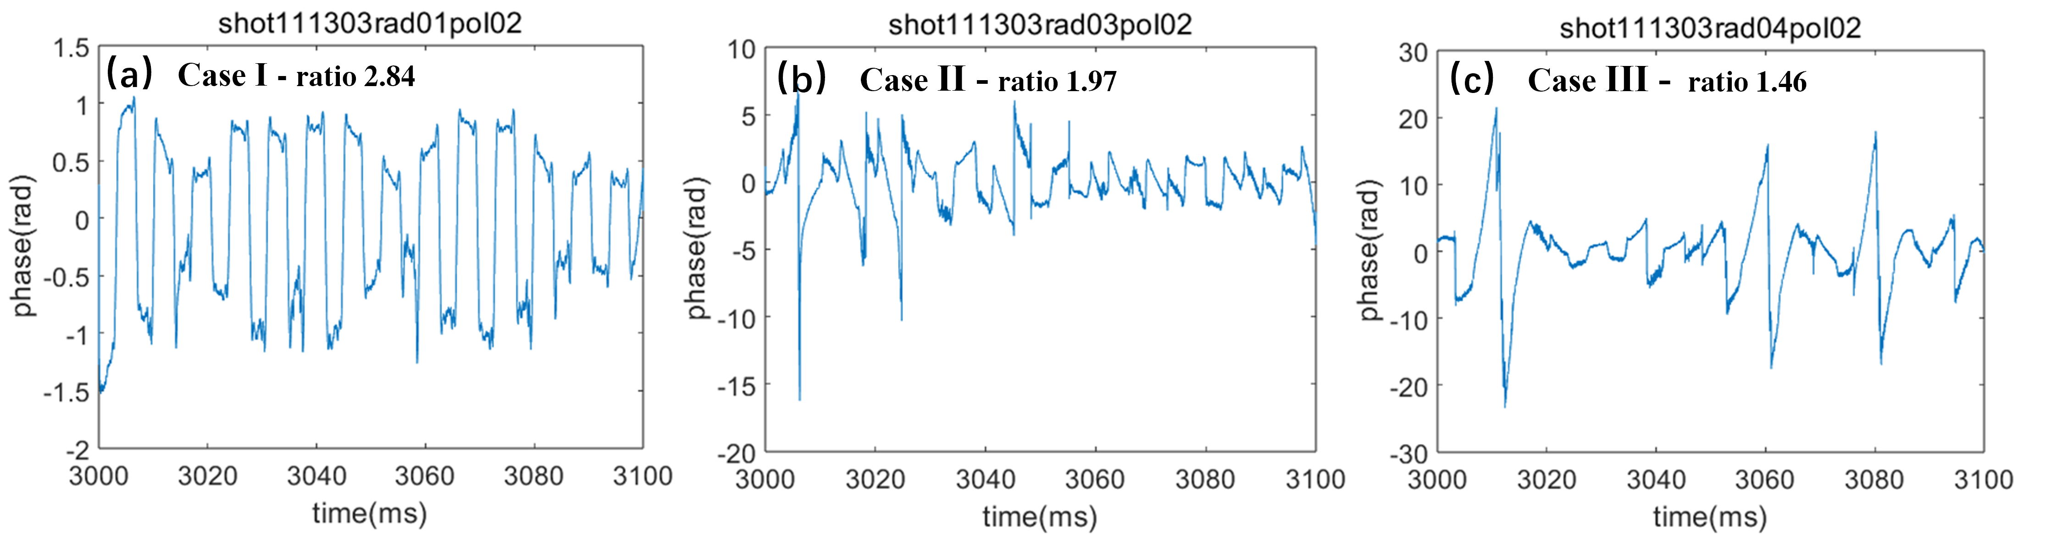

**Figure 9.** (a) The time sequence diagram of the disturbance phase when the power ratio is 2.84 with the introduction of spatial echoes; (b) & (c) The power ratios are 1.97 and 1.46 respectively.

The laboratory testing results shows the input power ratio should stand higher than 1.97 for the Hilbert-Huang Transform-based (HHT) for real-time phase measurement. The power ratio at reflection beam input stage should be above 1.97 for reliable density fluctuation measurement on EAST MIR system.

1. Preliminary EAST plasma results by the MIR system

In the first stage of MIR commissioning and operation on EAST, the system has realized the basic one-dimensional (in poloidal direction) diagnostic capability. The MIR system's transmitter source emits detection wave with single frequency at 70 GHz with 74 GHz LO frequency. The electronics module's local oscillator source provides a secondary mixing LO of 4140.05 MHz. In EAST shot # 141699, the optics coupling optimized for the poloidal channels # 3, # 4, and # 5 of the MIR receiver array effectively suppresses accidental reflections and enhances the signal-to-noise ratio of the original data. The poloidal channel # 6 has not been optimized. A coherent modes with frequencies between 60 kHz ~ 70 kHz are observed in the poloidal channel # 3, # 4, and # 5,as shown in Fig 10a, the optimized channel # 5 and the raw data of the unoptimized channel # 6 are shown in the Fig 10b.

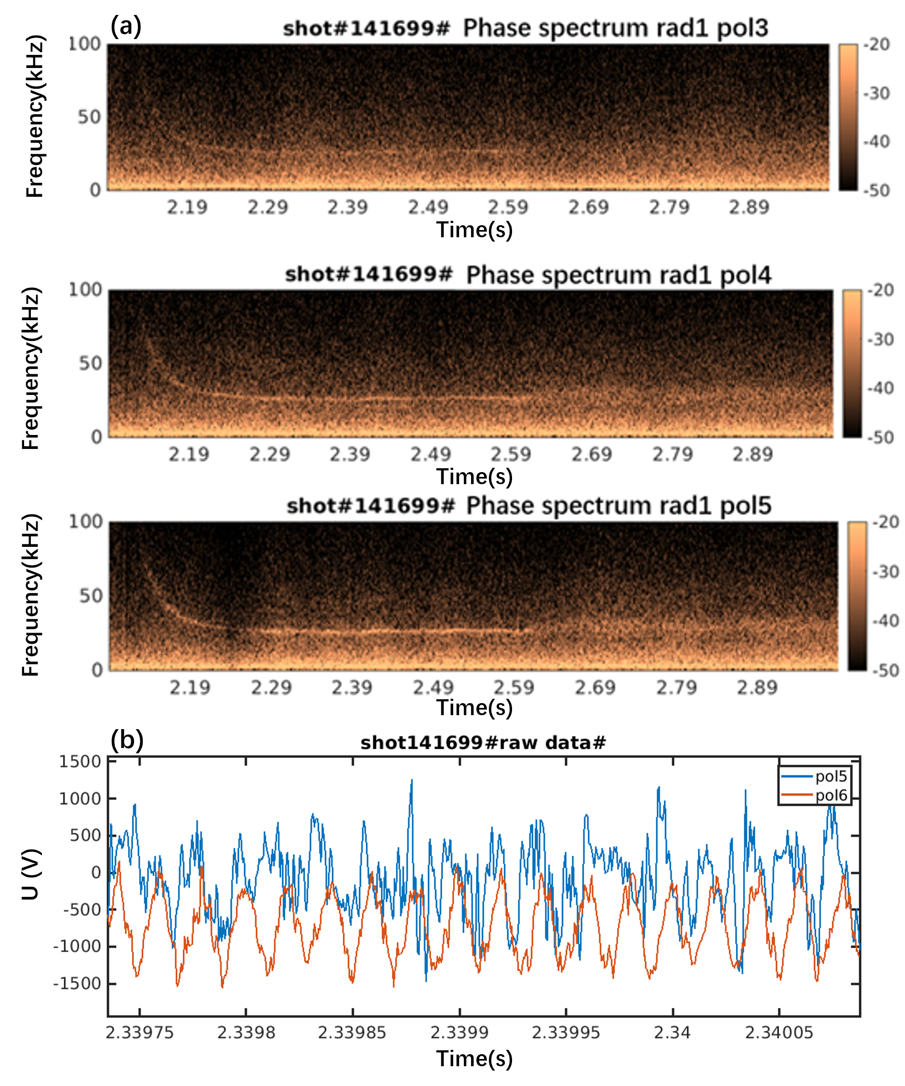

**Figure 10.** (a) Phase spectrum diagram of polodial channel 3、4、5 in EAST SHOT #141699;(b) the optimized channel 5 and the raw data of the unoptimized channel 6.

In EAST shot 141745, the phase and amplitude spectra of the fifth antenna are shown in Figure 11. A correlation analysis was performed between the fourth and fifth antennas over a 50 ms time window from 2.3s to 2.35s during the discharge, shown in Figure 12. The analysis results indicate the presence of coherent modes with frequency range between 60 kHz and 70 kHz.

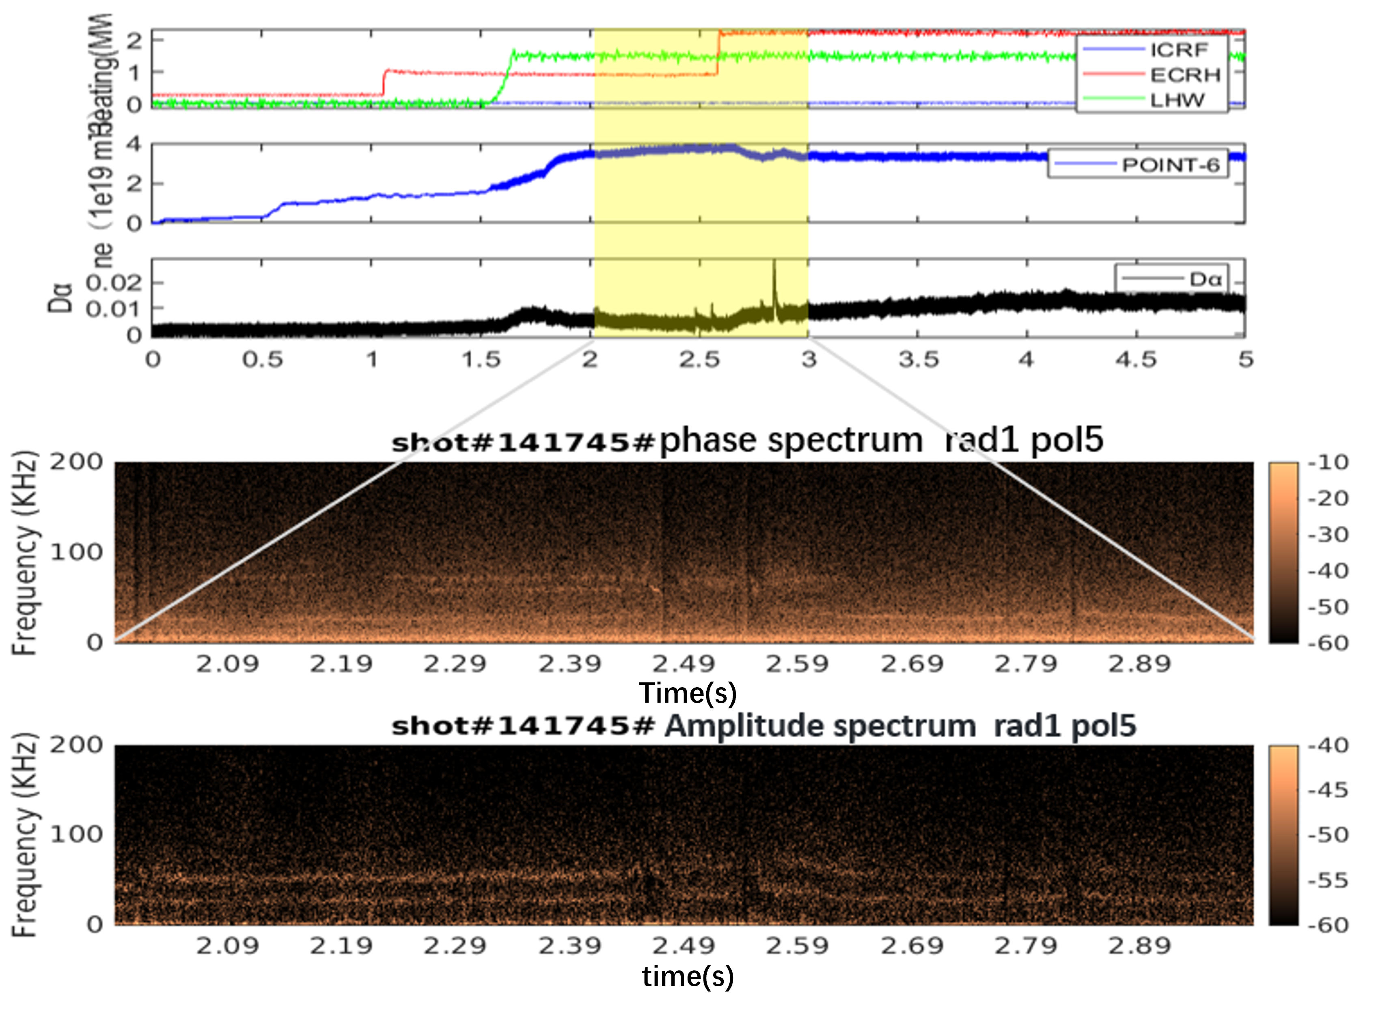

**Figure 11.** Phase and amplitude spectrum diagram of polodial channel 5 in EAST SHOT #141745.

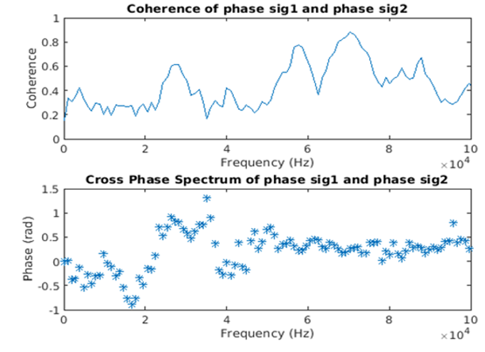

**Figure 12.** Correlation analysis between the channel 4 and 5 about EAST SHOT #141745.

1. Summary

The Microwave Imaging Reflectometer has been successfully developed and implemted on EAST for 2D electron density fluctuation measurement. The simultaneous receiving of the plasma reflection beam and unexpected reflections leads to distorted phase interpretation from plasma experimental raw data. Laboratory testing revealed that the signal-to-noise ratio of the input power must exceed 1.97 to reliably extract phase information, thereby enhancing the accuracy of density fluctuation measurements. The coherent modes have been observed in the EAST boundary plasma via MIR system. The MIR tuning up is still in investigation to achieve the expected 2-D density fluctuation evolution.

Acknowledgments

This work is supported by National Magnetic Confinement Fusion Energy Program of China under Contract No. 2019YFE03020001. The authors wish to thank the EAST group for the valuable help on the engineering design.

References

[1] E. Mazzucato et al., *Microwave imaging reflectometry for the visualization of turbulence in tokamaks*, Nucl. Fusion 41 (2001) 2.

[2] E. Mazzucato et al., *Microwave reflectometry for magnetically confined plasmas*, Rev. Sci. Instrum. 69 (1998) 6.

[3] E. Mazzucato, and R. Nazikian et al., *Microwave reflectometry for the study of density fluctuations in tokamak plasmas*, Plasma physics and controlled fusion 33.3 (1991): 261.

[4] E. Mazzucato, and R. Nazikian et al., *Radial scale length of turbulent fluctuations in the main core of TFTR plasmas*, Physical review letters 71.12 (1993): 1840.

[5] E. Mazzucato et al., *Numerical study of microwave reflectometry in plasmas with two-dimensional turbulent fluctuations*, Review of scientific instruments 69 (1998).

[6] R. Nazikian, C. J. Kramer, and E. Valeo, *A tutorial on the basic principles of microwave reflectometry applied to fluctuation measurements in fusion plasmas*, Phys. Plasmas, 8 (2001) 5.

[7] E. Mazzucato et al., *Fluctuation measurements in tokamaks with microwave imaging reflectometry*, Physics of Plasmas 9.5 (2002): 1955-1961.

[8] E. Mazzucato et al., *Microwave imaging reflectometry for the measurement of turbulent fluctuations in tokamaks*, Plasma physics and controlled fusion 46.8 (2004): 1271.

[9] T. Munsat et al., *Microwave imaging reflectometer for TEXTOR,* Review of scientific instruments 74 (2003): 1426-1432

[10] C. M. Muscatello et al., *Millimeter-wave imaging reflectometry on the DIII-D Tokamak,* Nuclear Fusion (2014).

[11] R. Sabot et al., *Development of Microwave Imaging Diagnostics for WEST Tokamak,* Journal of Fusion Energy 38 (2019) : 394-405.

[12] W. Lee et al., *Microwave imaging reflectometry for KSTAR,* Journal of Instrumentation 7 (2012): C01070.

[13] S. Yamaguchi et al., *Microwave imaging reflectometry in LHD*, Review of scientific instruments 77.10 (2006).

[14] Z. Shi et al., *Development of microwave imaging reflectometry on the HL-2A tokamak*, Review of Scientific Instruments 85.1 (2014).

[15] W. Liao et al., *Bench test of microwave imaging reflectometry system for EAST tokamak*, Journal of Instrumentation 15.03 (2020):C03036.

[16] Y. Zhu et al., *The general optics structure of millimeter-wave imaging diagnostic on tokamak*, Journal of Instrumentation, 11.01 (2016): P01004.

[17] T. Munsat et al., *Laboratory characterization of an imaging reflectometer system*, Plasma Phys. Controlled Fusion 45.4 (2003) :469.

[18] Y. Zhu, Zhao Z, Tong L et al., *Optics system design of microwave imaging reflectometry for the EAST tokamak*, Plasma Science and Technology 18 (2016) 4.

[19] Muscatello, Christopher M et al., *Technical overview of the millimeter-wave imaging reflectometer on the DIII-D tokamak*. Review of Scientific Instruments 85.11 (2014).